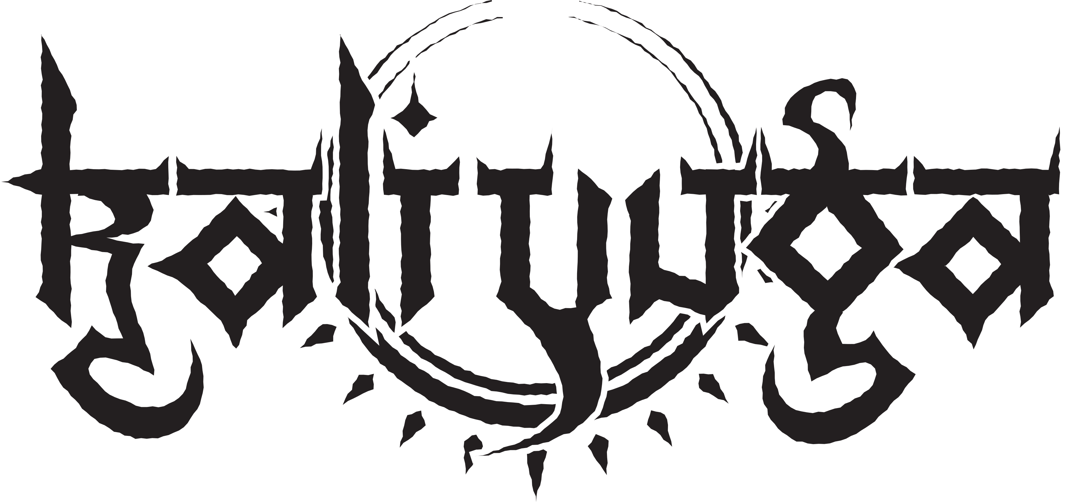
Band Biography

Initial Formation
At the end of 2006 the former Atanatos drummer Eik started to work on his own songs with his buddies Enrico (electric guitar) and David (vocals) to go new musical ways. When a drummer was found with Florian and after the end of Atanatos with Kocher a bass player was added to the line-up, a new independent band called Kali Yuga was formed. Since 2008 Kali Yuga has been performing their own songs at various clubs and festivals.

Line-up carousel
In 2009 there were some line-up changes: David was replaced by Grützer (also guitarist of Artless) and Enrico's job on the guitar was taken over by Michbert from Radiation Dust. By means of a promo CD Dead Shall Reign, recorded at the Rape of Harmonies Studio by Patrick W. Engel and Alexander Dietz in 2009, the band was able to attract the attention of various labels and finally signed a contract with G.U.C.. This was followed by performances together with Exodus, Graveworm, Dew-Scented, Watain and Tankard. The first album Slaves to the Subliminal was released in February 2011. In 2012 Jean joined the band and took over the drummer position. This was followed by various other performances, including concerts at Party.San or Hell Inside Festival. On November 1, 2012 the next record Wrath of Durga was released.

A new voice
After Grützer announced his retirement from the mic in 2017, a suitable successor was finally found in Christian in 2018 after a long search. The songs created in the meantime were lyricized. Old and new songs were presented live until the Corona pandemic threw a wrench in the boys' plans. During this time the recording of the upcoming album Lord of Lies started on their own. A release is expected for the turn of the year 2023/24.

E-Mail: kontakt@kali-yuga.de
Tel.: +49 173 5611689 (Eik Halle)
Homepage: www.kali-yuga.de
Facebook: facebook.com/kaliyugametal

